Irregular Shapes
# Source: AI Source: Provided by: [Data Path: Persons Table -> ID Column: 1, Name_En Column: Motasem Essam] -> From: [ChatGPT] on [7/25/2026]
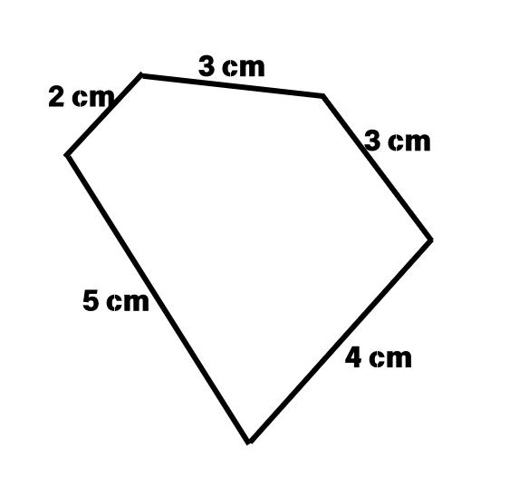
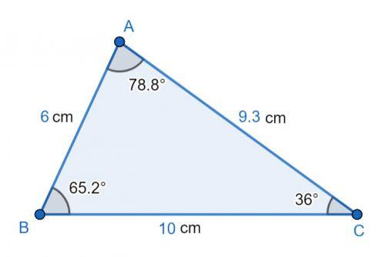
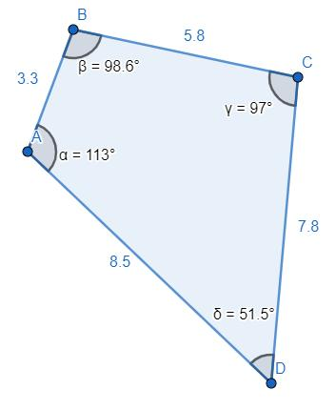
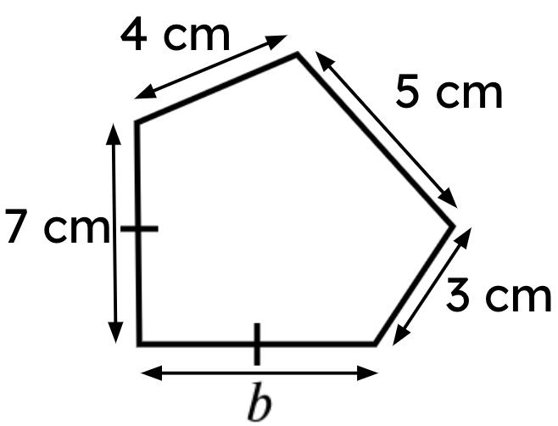
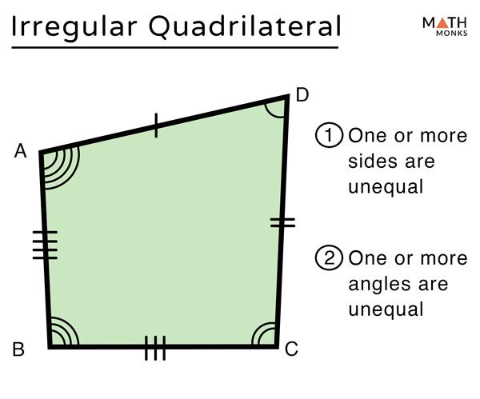
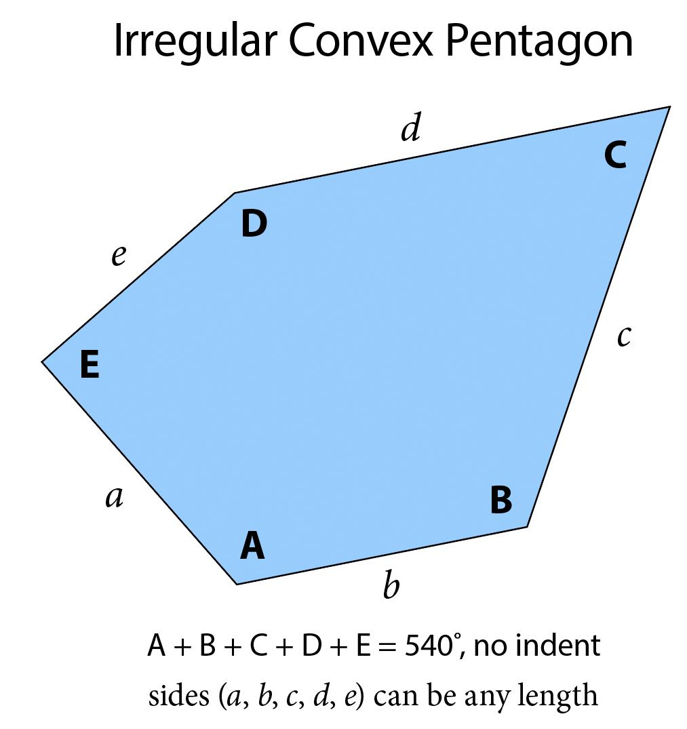

Definition
# Source: AI Source: Provided by: [Data Path: Persons Table -> ID Column: 1, Name_En Column: Motasem Essam] -> From: [ChatGPT] on [7/25/2026]
An Irregular Shape is a two-dimensional geometric figure in which the sides and/or angles are not all equal.
Unlike regular shapes, irregular shapes do not have complete uniformity or equal measurements. They may have:
- Different side lengths.
- Different angle measures.
- Different levels of symmetry.
Irregular shapes can be formed from:
- Straight line segments (irregular polygons).
- Curved boundaries.
- A combination of straight and curved boundaries.

Characteristics
# Source: AI Source: Provided by: [Data Path: Persons Table -> ID Column: 1, Name_En Column: Motasem Essam] -> From: [ChatGPT] on [7/25/2026]
An irregular shape:
- Is a 2D geometric figure.
- Has unequal sides and/or angles.
- May be symmetrical or asymmetrical.
- May have straight, curved, or mixed boundaries.
- Can be open or closed (although geometric shapes are usually closed).
- Has measurable properties such as:
  - Area
  - Perimeter
  - Angles
  - Side lengths

Illustration

Irregular Triangle (Scalene Triangle)
# Source: AI Source: Provided by: [Data Path: Persons Table -> ID Column: 1, Name_En Column: Motasem Essam] -> From: [ChatGPT] on [7/25/2026]
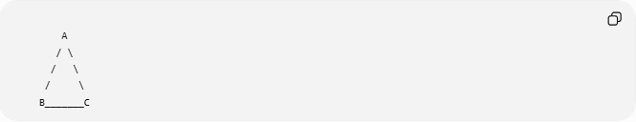
A
/ \
/ \
/ \
B_______C
Properties:
- All sides have different lengths.
- All angles may be different.

Irregular Quadrilateral
# Source: AI Source: Provided by: [Data Path: Persons Table -> ID Column: 1, Name_En Column: Motasem Essam] -> From: [ChatGPT] on [7/25/2026]
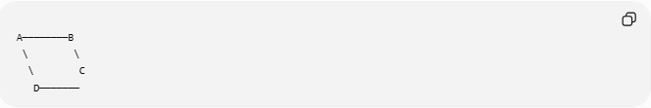
A────────B
\ \
\ C
D───────
Properties:
- Sides are not equal.
- Angles are not equal.

Irregular Polygon
# Source: AI Source: Provided by: [Data Path: Persons Table -> ID Column: 1, Name_En Column: Motasem Essam] -> From: [ChatGPT] on [7/25/2026]
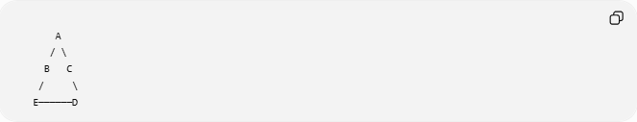
A
/ \
B C
/ \
E──────D
The sides and angles vary.

Mathematical Representation
# Source: AI Source: Provided by: [Data Path: Persons Table -> ID Column: 1, Name_En Column: Motasem Essam] -> From: [ChatGPT] on [7/25/2026]
An irregular polygon can be represented by vertices:
$$P_{1},P_{2},P_{3},…,P_{n}$$
where side lengths are not necessarily equal:
$$\left|P_{1}P_{2}\right|≠\left|P_{2}P_{3}\right|$$
and interior angles may differ:
$$∠A≠∠B≠∠C$$

Types of Irregular Shapes

1. Irregular Polygonal Shapes
# Source: AI Source: Provided by: [Data Path: Persons Table -> ID Column: 1, Name_En Column: Motasem Essam] -> From: [ChatGPT] on [7/25/2026]
Made entirely of straight line segments.
Examples:
- Scalene triangle.
- Irregular quadrilateral.
- Irregular pentagon.

2. Irregular Curved Shapes
# Source: AI Source: Provided by: [Data Path: Persons Table -> ID Column: 1, Name_En Column: Motasem Essam] -> From: [ChatGPT] on [7/25/2026]
Made with curved boundaries.
Examples:
- Natural stones.
- Leaves.
- Lakes.
- Clouds.

3. Irregular Mixed Shapes
# Source: AI Source: Provided by: [Data Path: Persons Table -> ID Column: 1, Name_En Column: Motasem Essam] -> From: [ChatGPT] on [7/25/2026]
Contain both straight and curved boundaries.
Examples:
- Irregular architectural designs.
- Product shapes.
- Mechanical parts.

Examples
Example 1 – Scalene Triangle
A triangle with:
- Three unequal sides.
- Three unequal angles.

Example 2 – Irregular Pentagon
A five-sided figure where:
- Side lengths differ.
- Angles differ.

Example 3 – Natural Shapes
Examples:
- Tree leaves.
- Rocks.
- Islands.
- Human body outlines.

Properties
# Source: AI Source: Provided by: [Data Path: Persons Table -> ID Column: 1, Name_En Column: Motasem Essam] -> From: [ChatGPT] on [7/25/2026]
1. Unequal Measurements
Unlike regular shapes:
$${\text{Side}}_{1}≠{\text{Side}}_{2}$$

2. Variable Angles
Interior angles may have different values.

3. Lower Symmetry
Many irregular shapes have:
- No lines of symmetry.
- No rotational symmetry.

4. Complex Calculations
Area and perimeter often require:
- Decomposition into simpler shapes.
- Coordinate methods.
- Numerical methods.

Area of Irregular Shapes
# Source: AI Source: Provided by: [Data Path: Persons Table -> ID Column: 1, Name_En Column: Motasem Essam] -> From: [ChatGPT] on [7/25/2026]
The area of an irregular shape can be found using:
1. Decomposition
Divide the shape into simpler figures:
$$A=A_{1}+A_{2}+A_{3}+⋯$$
Example:
- Rectangles
- Triangles
- Circles

2. Coordinate Geometry
Using vertex coordinates:
$$A=\frac{1}{2}\left|\sum_{i=1}^{n}{\left(x_{i}y_{i+1}-x_{i+1}y_{i}\right)}\right|$$
(Shoelace formula)

3. Approximation Methods
Such as:
- Grid counting.
- Numerical integration.
- Computer algorithms.

Real-World Examples
# Source: AI Source: Provided by: [Data Path: Persons Table -> ID Column: 1, Name_En Column: Motasem Essam] -> From: [ChatGPT] on [7/25/2026]
Irregular shapes appear everywhere:
- Countries and borders.
- Lakes and islands.
- Trees and leaves.
- Rocks.
- Clouds.
- Human body parts.
- Furniture designs.
- Industrial components.

Applications
# Source: AI Source: Provided by: [Data Path: Persons Table -> ID Column: 1, Name_En Column: Motasem Essam] -> From: [ChatGPT] on [7/25/2026]
Irregular shapes are used in:
- Plane Geometry
- Surveying
- Geography
- GIS (Geographic Information Systems)
- Engineering
- Architecture
- Biology
- Medicine
- Computer Graphics
- CAD (Computer-Aided Design)

Advantages
# Source: AI Source: Provided by: [Data Path: Persons Table -> ID Column: 1, Name_En Column: Motasem Essam] -> From: [ChatGPT] on [7/25/2026]
Studying irregular shapes helps to:
- Model real-world objects.
- Analyze complex structures.
- Calculate areas of natural regions.
- Design unique products.
- Understand non-uniform geometry.

Limitations
# Source: AI Source: Provided by: [Data Path: Persons Table -> ID Column: 1, Name_En Column: Motasem Essam] -> From: [ChatGPT] on [7/25/2026]
Irregular shapes:
- Have more complex calculations.
- Usually require advanced methods.
- Lack simple formulas compared with regular shapes.

Comparison with Regular Shapes
# Source: AI Source: Provided by: [Data Path: Persons Table -> ID Column: 1, Name_En Column: Motasem Essam] -> From: [ChatGPT] on [7/25/2026]
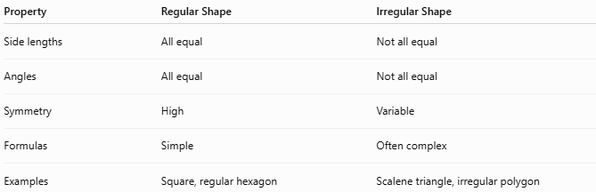
Property | Regular Shape | Irregular Shape
Side lengths | All equal | Not all equal
Angles | All equal | Not all equal
Symmetry | High | Variable
Formulas | Simple | Often complex
Examples | Square, regular hexagon | Scalene triangle, irregular polygon

Key Points
# Source: AI Source: Provided by: [Data Path: Persons Table -> ID Column: 1, Name_En Column: Motasem Essam] -> From: [ChatGPT] on [7/25/2026]
- An Irregular Shape does not have equal sides and equal angles.
- It may have:
  - Straight boundaries.
  - Curved boundaries.
  - Mixed boundaries.
- Examples include:
  - Scalene triangles.
  - Irregular polygons.
  - Natural shapes.
- Irregular shapes often require advanced methods for measurement.

Conclusion
# Source: AI Source: Provided by: [Data Path: Persons Table -> ID Column: 1, Name_En Column: Motasem Essam] -> From: [ChatGPT] on [7/25/2026]
An Irregular Shape is a two-dimensional geometric figure whose sides and/or angles are not all equal. Unlike regular shapes, irregular shapes do not follow uniform measurements, making their analysis more complex. They are essential in plane geometry, surveying, GIS, engineering, architecture, biology, medicine, CAD, and computer graphics, where they are used to represent and analyze the many non-uniform shapes found in mathematics and the real world.

